"Kyiv Vocational College of Communication"

Cyclic Commission of Computer Engineering

EXECUTION REPORT

**Work - Case #6**

**from the discipline: "Operating systems"**

**Topic:** WORK-CASES IN LINUX

a list of additional practical tasks

from the discipline "Operating Systems"

It was performed by students of the RPZ group - 03B

Team 6: Sichkar Maxim,

Brytyuk Bohdan

Kyiv 2023

**Work-case 6**

1. Several command interpreters must be installed in the workspace of the operating system (in addition to bash, there are 2 more of your choice):

- What teams can do it;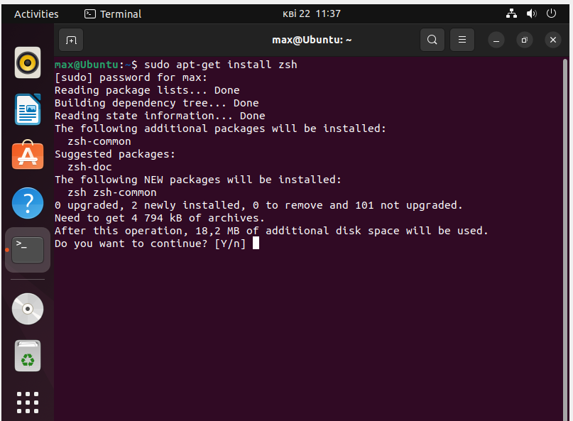

- Briefly describe the capabilities of each of them.

Zsh (Z Shell) is a shell for UNIX-like operating systems. It is an extension to the traditional Bourne shell (sh) shell and has several additional features and capabilities.

The main advantages of zsh over other command interpreters:

Autocompletion: zsh offers automatic completion of commands, options, and file names, which allows you to work more efficiently and quickly with the system.

Command History: zsh stores a history of commands you typed, allowing you to quickly repeat previous actions.

Ability to edit commands: zsh allows you to edit a command before it is executed, which reduces the number of errors and helps in efficient use of time.

Scripting support: zsh supports the development and execution of scripts, allowing you to automate routine actions.

2. It is necessary to create 10 new users in your system and distribute them to groups:

- Technical support (technical support, system administrators);

- Developers (developers, technical specialists of their profile);

- Financiers (accounting, economists, etc.);

- Founders (management);

- Guests (guests).

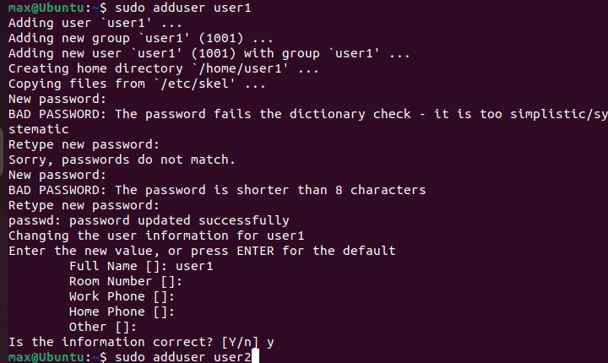

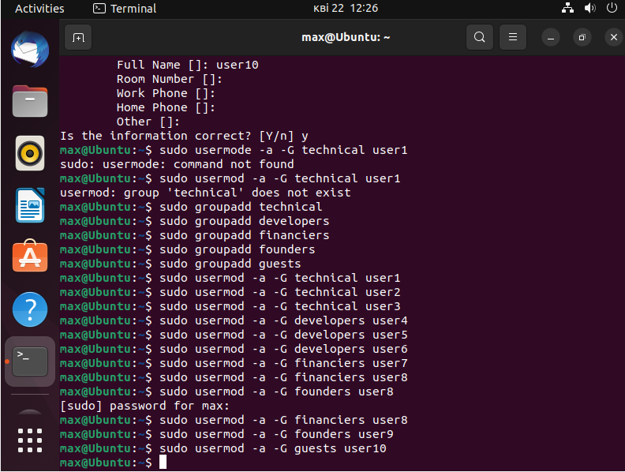

3. For each user, define its default command interpreter:

- Technical support – bash;

- Developers – command interpreter 1 (task 1);

- Financiers – deny access to team interpreters;

- Founders – command interpreter 2 (task 1);

- Guests – deny access to command interpreters

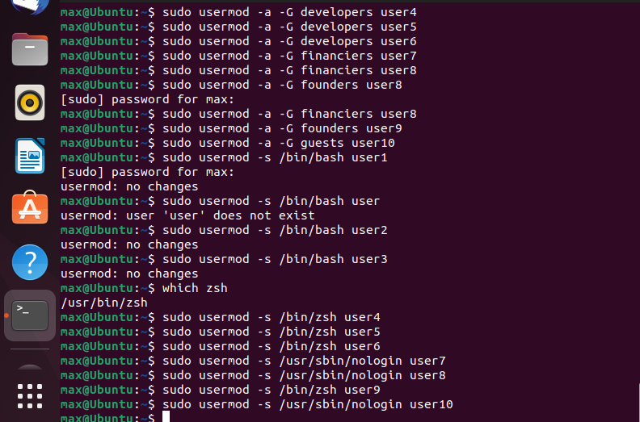

4. Demonstrate examples of how each user group works in their command interpreter - for example, gathering information about the system, determining the basic configuration, system date, current directories, etc. 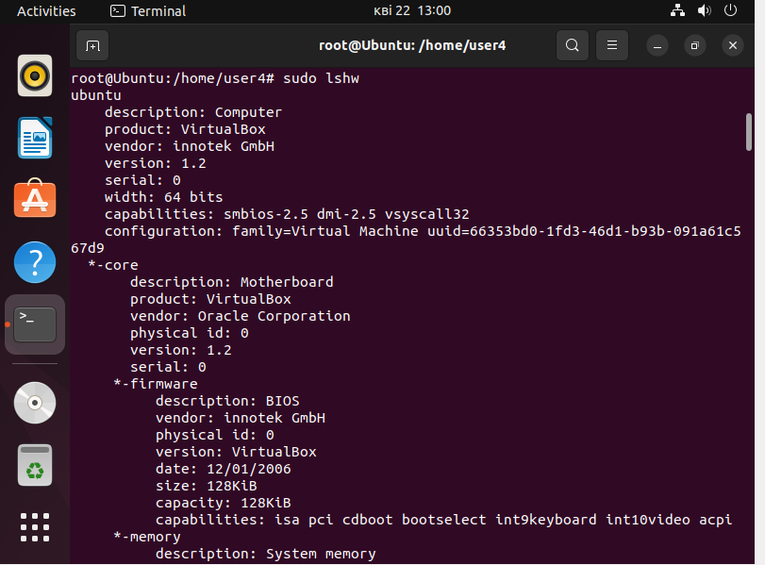

Conclusion: I got used to creating new users, new groups. Allowing and disallowing the flap to different interpreters.